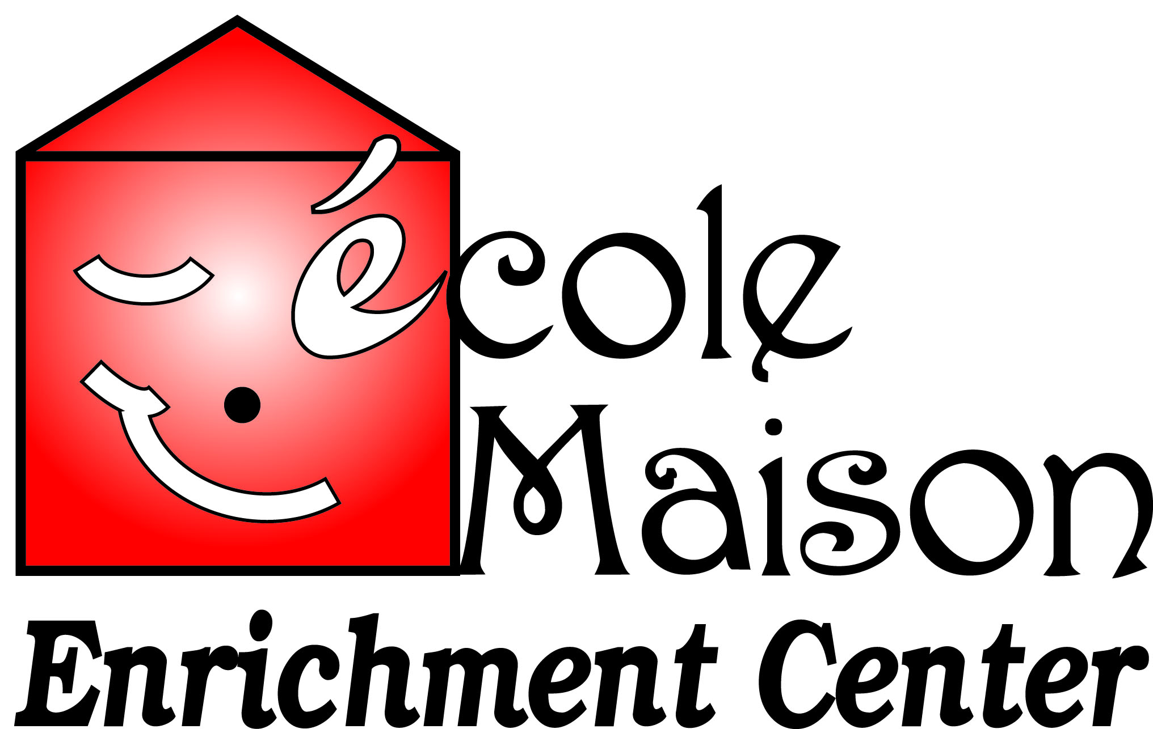

Ages & Stages Questionnaires

Dear École Maison Families,
As you are aware, École Maison is now a Step Up To Quality star rated center! Because we are a participating SUTQ center, we are required to administer developmental screening for all children enrolled. Don’t worry, the screening is very easy to administer and takes no time at all!
The first 5 years of your child’s life are extremely important and we want to help you provide the best start for your child. As part of this service, we provide the Ages & Stages Questionnaires, Third Edition (ASQ-3) and Ages & Stages: Social Emotional to help you keep track of your child’s development. A questionnaire will be provided within 60 days of enrollment and annually thereafter. You will be asked to answer questions about some things your child can do. The questionnaire includes questions about your child’s communication, gross motor, fine motor, problem solving and personal-social skills.
If the questionnaire shows that your child is developing without concerns, we will continue to provide age appropriate activities to encourage your child’s development and will conduct the next assessment the following year.
If the questionnaire shows some possible concerns, we may reevaluate after a few months or recommend and discuss the next steps. No information will be shared with other agencies without your written consent.
We look forward to your participation in our program and hope you experience the benefits of our involvement with SUTQ. As always, if you have any questions or concerns, we are always available to discuss. Thank you!
Sincerely,

Wendy McPherson Angie Blankenship Naureen Sharif
Owner Director Assistant Director

